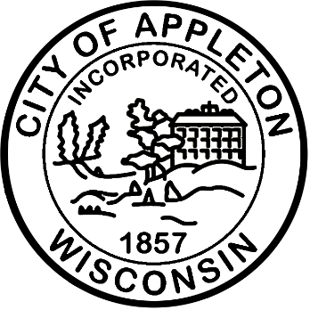
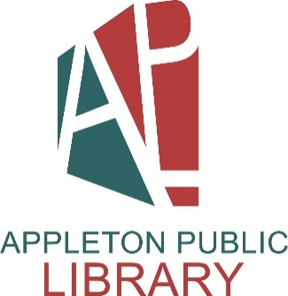

City of Appleton
Library Page

The Appleton Public Library, the Wisconsin Library of the Year for 2025, is seeking a Library Page to join our dynamic team.

Library Pages maintain the arrangement of library materials, shelve materials, shift, and pick up materials left throughout the library. Pages gather materials requested on the reserve list and place them on the hold shelves. This position is part-time, non-benefited. The position will work 10-16 hours a week with a flexible schedule. Work is supervised by a section assistant supervisor and the section supervisor.

Qualifications
This position requires at least two years of high school education or a combination of applicable experience and training.

Salary
The starting wage for this position is $11.57 hourly.

Apply Now!
If you are interested in applying for this position, please complete an on-line application at appletonwi.gov/careers by no later than Sunday, August 2, 2026. Resumes without an application will not be considered.

City of Appleton Human Resources
100 N. Appleton Street, 6th floor
Appleton, WI 54911
Phone: (920) 832-6458
Email: humanresources@appletonwi.gov
Equal Opportunity Employer

